Business Rules

Description
This document describes the configuration of UI Policies used to control dynamic form behaviour for the Employee Onboarding & Offboarding Service Catalog in ServiceNow. These rules dynamically show or hide fields based on user input, improving data accuracy and overall user experience without using client scripts.
Purpose
- Enforce conditional visibility of onboarding and offboarding form fields
- Reduce incomplete or incorrect submissions
- Improve usability through dynamic form behaviour
- Maintain clean and script-free configurations using UI Policies

UI Policy Scenario
Scenario 1: Onboarding
Condition:
If the Request Type is set to Onboarding, the Joining Date field should be displayed and marked as mandatory.
Scenario 2: Offboarding
Condition:
If the Request Type is set to Offboarding, the Exit Date field should be displayed and marked as mandatory.

Configuration Details

Catalog UI Policy Setup – Onboarding
- Navigate to Service Catalog > Maintain Items
- Open the Onboard New Employee catalog item
- Navigate to Catalog UI Policies
- Click New and configure:
  - Applies to: Catalog Item
  - Catalog Item View: Enabled
  - Short Description: Show Joining date for Onboarding
- Set condition:
  - Request Type is Onboarding
- Enable:
  - On load
  - Reverse if false
- Save the UI Policy

UI Policy Action – Onboarding
- Open UI Policy Actions from the related list
- Configure the variable joining_date with:
  - Visible: True
  - Mandatory: True
- Save the UI Policy Action
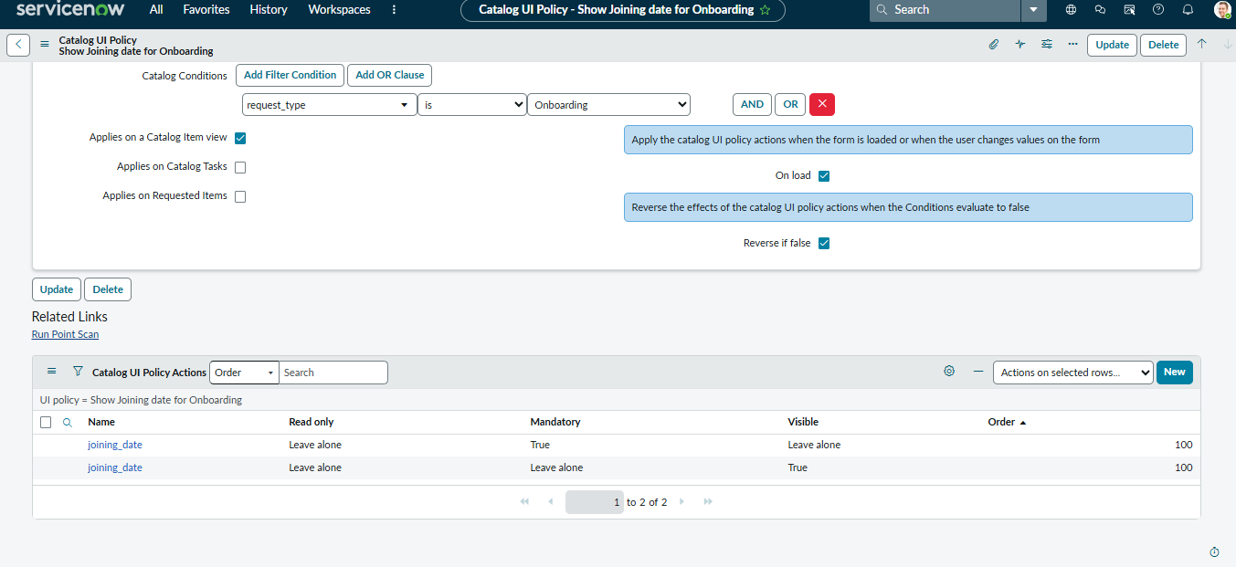

Catalog UI Policy Setup – Offboarding
- Navigate to Service Catalog > Maintain Items
- Open the Onboard New Employee catalog item
- Navigate to Catalog UI Policies
- Click New and configure:
  - Applies to: Catalog Item
  - Catalog Item View: Enabled
  - Short Description: Show Exit date for Offboarding
- Set condition:
  - Request Type is Offboarding
- Enable:
  - On load
  - Reverse if false
- Save the UI Policy

UI Policy Action – Offboarding
- Open UI Policy Actions from the related list
- Configure the variable exit_date with:
  - Visible: True
  - Mandatory: True
- Save the UI Policy Action
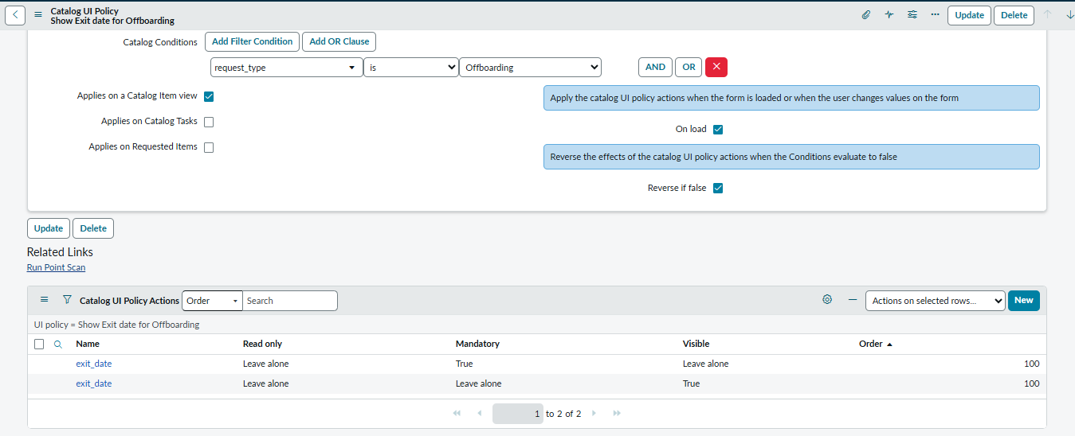

Testing & Validation
• Open the Onboard New Employee catalog item in the Service Portal
• Select Onboarding as the request type
- Verify that Joining Date becomes visible and mandatory
• Select Offboarding as the request type
- Verify that Exit Date becomes visible and mandatory
• Change request type and confirm fields hide automatically when conditions are not met

Outcome
• Dynamic and context-specific form behaviour achieved using UI Policies
• Accurate capture of onboarding and offboarding dates
• Improved user guidance and data quality
• Reduced dependency on client scripts and easier maintenance
